FACULTY OF INFORMATION MANAGEMENT

UNIVERSITI TEKNOLOGI MARA

MERBOK, KEDAH

Diploma in Information Management

(IM110)

Introduction to Web Content Management and Design

(IMD311)

**GROUP PROJECT REPORT:**

**“ROCKET FIRE CORPORATE WEBSITE”**

Prepared by:

|  |  |
| --- | --- |
| SITI SUHAILA BINTI SHARIF | 2020477854 |
| SITI HAWA HUMAYRA BINTI MOHD FAHIZAL | 2020600346 |
| MUHAMMAD ZHAFRAN BIN ZAURI | 2020626836 |
| MUHAMMAD HAFIZ BIN MOHD RAFI | 2020492082 |

Class: KIM1105A

Prepared for:

SIR AIRUL SHAZWAN NORSHAHIMI

Submission Date: 6 FEBRUARY 2023

**GROUP PROJECT REPORT:**

**“ROCKET FIRE CORPORATE WEBSITE”**

Prepared by:

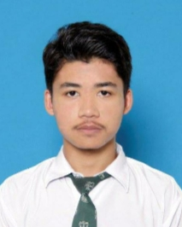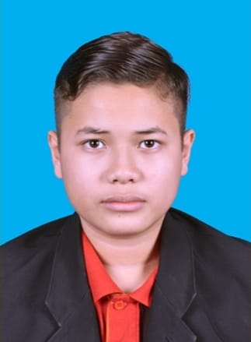

FACULTY OF INFORMATION MANAGEMENT

UNIVERSITI TEKNOLOGI MARA

MERBOK, KEDAH

Submission Date: 6 FEBRUARY 2023

**ACKNOWLEDGEMENT**

Assalamualaikum w.b.t, first, we would like to thank Allah SWT and His Messenger, Prophet Muhammad SAW as I were finally able to finish our Group Project. A special gratitude we gave to our supportive Lecturer Sir Airul Shazwan Norshahimi, whose contribution in simulating suggestions and encouragement, helped us to coordinate our assignment especially in writing this report.

On the other hand, we would like to thank our family who has continuously support and encourage us from behind to complete this project and always pray for our success. In addition, we also want to thank to our classmates who had shared their ideas and help us to complete this project.

**TABLE OF CONTENT**

|  |  |  |
| --- | --- | --- |
| **NO** | **CONTENT** | **PAGE** |
| ACKNOWLEDGEMENT | | i |
| 1.0 | INTRODUCTION | 1 |
| 2.0 | PLANNING |  |
| 3.0 | ANALYSIS DISCUSSION |  |
| 4.0 | PROTOTYPING AND REVIEW |  |
| 5.0 | DEVELOPMENT AND TESTING |  |
| 6.0 | RELEASE AND SEARCH ENGINE OPTIMIZATION (SEO) |  |
| 7.0 | MAINTENANCE |  |
| 8.0 | CONCLUSION |  |
| 9.0 | REFERENCES |  |

1. **INTRODUCTION**

In this group project, we will develop a corporate website. Our corporate website is a website about a company that produce an application for their users. Our company name is Rocket Fire, Rocket Fire is a company that provided service to their customers. The first service that our company want to develop is “Meas It!”, it is an application for customers to measure their body size when they want to buy clothing online or to reduce time consumption when they buy at cloth store. We develop this application due to the problems that we hear from nearby people that need something to reduce time when they are shopping offline or online. We believe that people nowadays need new technology because most people are workaholic persons that do not have time for buying their needs.

In our corporate website have 6 pages which is Homepage that have our company name and our tagline. Next is About Us that we explain about our company logo. Then is About Logo which is this part we describe about our application logo that we want to develop. For the next page is Services, we explain about service that we provided in our company and our applications. Then, there is also the page for other’s information that have corporate video about our applications and our organizational charts. The last page is about contact that everyone can reach us by clicking the icon or any contact link that will directed to us. We have been together to finish up our group project corporate website.

1. **PLANNING**

*ORGANIZATIONAL CHART*

*TASK AND RESPONSIBILITIES*

|  |  |  |
| --- | --- | --- |
| **NAME** | **TASK** | **RESPONSIBILITIES** |
| SITI SUHAILA BINTI SHARIF | PROJECT MANAGER | * Played a big role in dividing members into the task and directing the completion of the project and make sure that the project finished within the time given. * Involved in helping the coder to develop the project * Involved in create the content |
| SITI HAWA HUMAYRA BINTI MOHD FAHIZAL | CONTENT DEVELOPER | * Played a role in developing content in website such as determine the name of the company, applications, description of the company on the website. * Do a copywriting and updating the website. * Contribute to brainstorming for the website content. |
| MUHAMMAD ZHAFRAN BIN ZAURI | CODER | * Played a role in transferring all information and design into codes. * Help in providing materials and designing website pages and elaborate more information in websites. * Helps in brainstorming an idea for a systematic website design and layout |
| MUHAMMAD HAFIZ BIN MOHD RAFI | EDITOR | * Responsible for the content and image use on the website. * Planning for a picture or content that used on the website. * Contribute to brainstorming for website content |

1. **ANALYSIS DISCUSSION**

Our website is focused on simple concept and not loaded information to make the audience are easy and enjoy surfing our website. We keep our website simple and clean despite of the dark color. We think as teenager’s user more like it because it is more comfortable to read anytime and anywhere. The content that we use in our website are not to crowded and to compact, so it is easier for users to read.

|  |  |  |
| --- | --- | --- |
| **WEBSITES** | **STRENGTH** | **WEAKNESSES** |
| DISCORD | * **Color and readability**   Contrast is the most important aspect associated with text readability. The background color and text color of the website should have a sharp contrast to allow the viewer to read the content of the site better. Discord's strategy is to use a light background with dark text or vice versa to make the website more attractive and comfortable for users. | * **Not chunking with information**   The information given could not be detected with important content and irregular order in conveying information. |
| CALAQISYA | * **Designing well thought out link**   Calaqisya website design are well designing that links get the users from page to page and it is users friendly that when users entered the websites it is not packed with too much information. | * **Font use**   In Calaqisya its use boring font that are not very attractive to users. The font use is like all types of content. The website is attractive only by the colour itself only. |
| UiTM KEDAH WEBSITE | * **Accessibility**   In term of accessibility, this website was able to provide a good presentation on delivering their content. User can understand well on how to use the website and what the website uses for.   * **Interface**   As for the interface, the website use colour that are suitable and pleasant to look at. In term of font, it uses more than three fonts, but the type of the font is suitable and did not make the website look too crowded. | * **Content**   Overall, this website can deliver about the content nicely however, some of the poster and images are not align with each other. But it is only slightly different.   * **Design**   The design also can be updated to the newest following the growth of our digital area. |
| EMERALD INSIGHT | * **Easy to use**   Emerald insight’s main page or home page does not contain too many details and just a few options and a big search bar in the middle of the page. It makes the search of materials are easier and do not require any complicated steps. The users only need to put in the keywords in the search to what the needed or related materials.   * **Optimized for mobile**   The website not only looks great on laptop or computer style, but it has been optimized to perform as well as it is in others platform such as tablets and mobile phones. Users can also access through their website by using any comfortable platforms. | * **Lack of sufficient guide**   For new users or visitors, they may not know how to use the website the right way, a proper guide must be added at the home or main page of the website.   * **Complex design**   When you use the search bar to find a material, the result page appears with many kinds of related materials which make it harder to find what the users what and it is hard to determine which materials are the most suitable or closest to what the users search. |
| DAILY HEALTH TIPS | * **Designing well though**   A good web design is easy to use, aesthetically pleasing, and suits the user group and brand of the website. This website is designed with a focus on simplicity, so that no extraneous information and functionality that might distract or confuse users appears. | * **Inappropriate fonts**   The font used in the application and website does not coincide with the design combination made because the size is too small and cannot be distinguished between the content and the title. |

1. **PROTOTYPING AND REVIEW**
   1. SKETCH PROTOTYPE

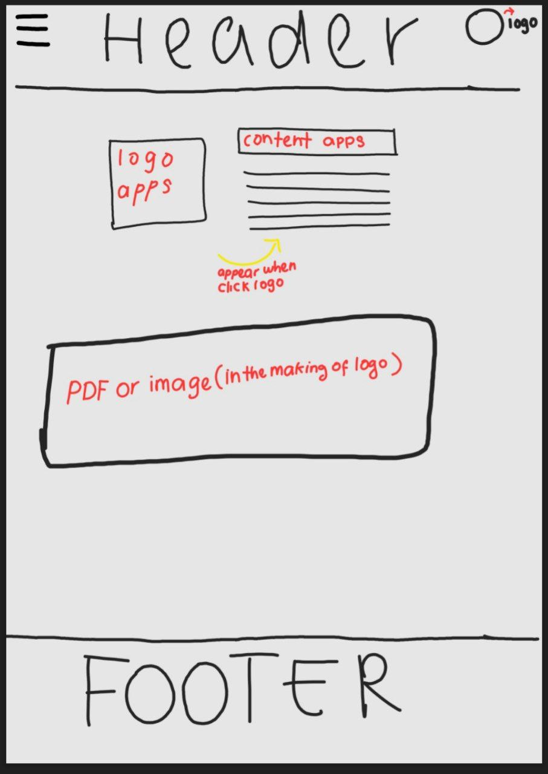

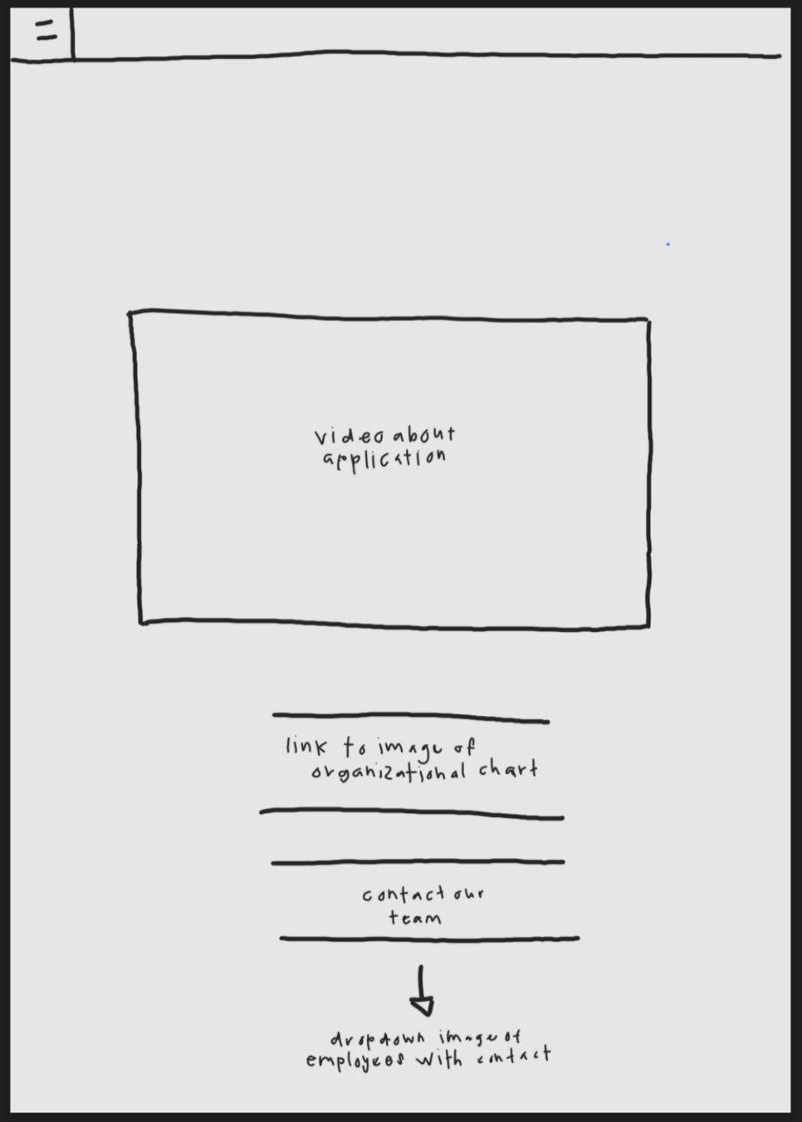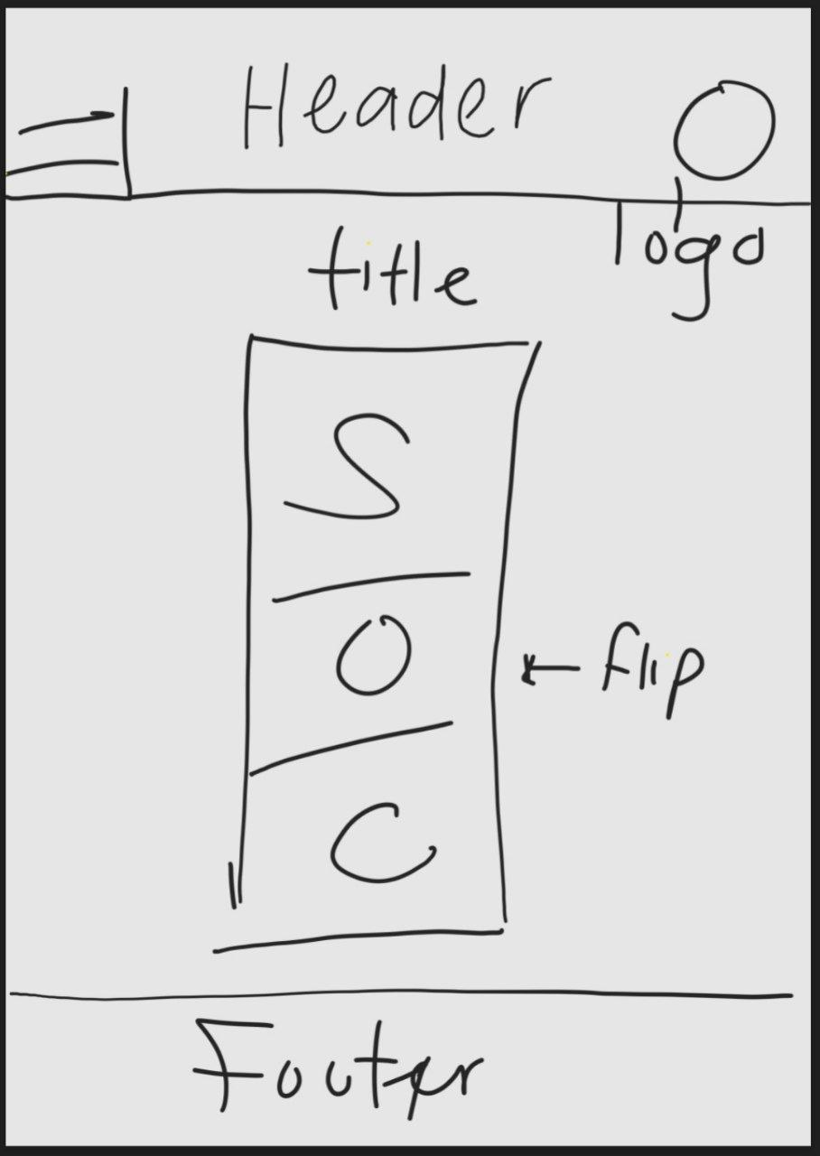

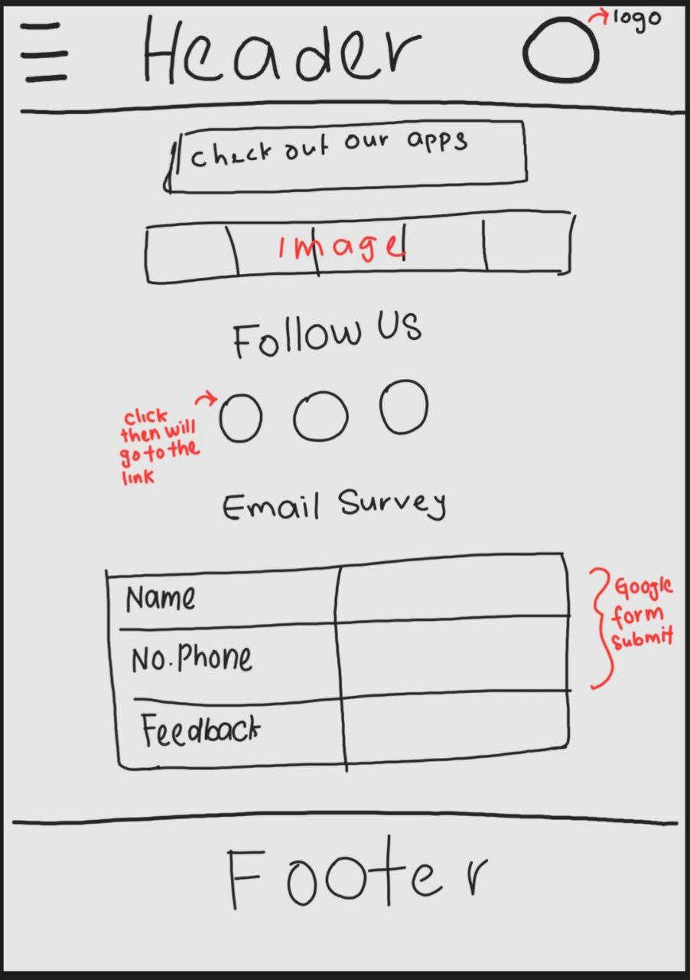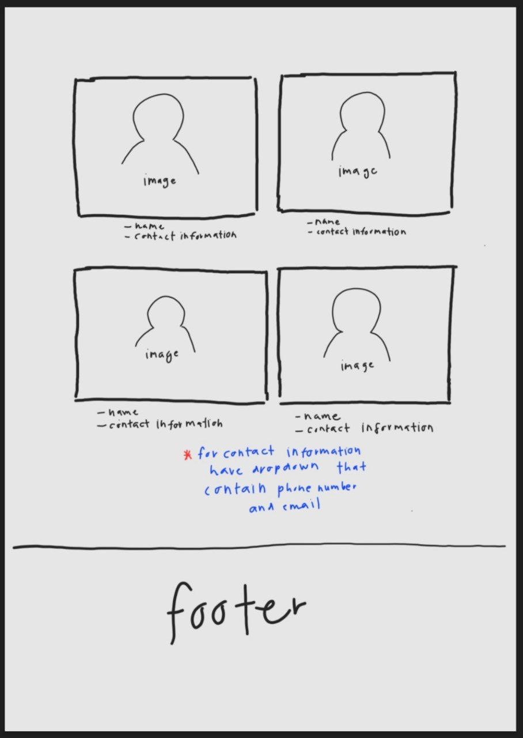

FOOTER

TAGLINE

CONTACT

OTHERS

SERVICES

ABOUT LOGO

ABOUT US

HOME

LOGO

TAGLINE

LOGO OF OUR APPS

EXPLANATION ABOUT OUR COMPANY LOGO

SLIDESHOW

FOOTER

CONTACT

OTHERS

SERVICES

ABOUT LOGO

ABOUT US

HOME

LOGO

SKETCH OF OUR LOGO APPS IN PDF

EXPLANATION ABOUT OUR LOGO APPS

LOGO OF THE COMPANY

FOOTER

CONTACT

OTHERS

SERVICES

ABOUT LOGO

ABOUT US

HOME

LOGO

DROPDOWN

EASY

CALCULATE BOY STATS

MEASURE

OUR SERVICES

FOOTER

CONTACT

OTHERS

SERVICES

ABOUT LOGO

ABOUT US

HOME

LOGO

DROPDOWN

VIDEO CORPORATE

ORGANIZATIONAL CHARTS

CONTACT TEAM

FOOTER

CONTACT

OTHERS

SERVICES

ABOUT LOGO

ABOUT US

HOME

LOGO

ICON

GOOGLE FORM

PICTURE

PICTURE

PICTURE

FOOTER

CONTACT

OTHERS

SERVICES

ABOUT LOGO

ABOUT US

HOME

LOGO

FOOTER

CONTACT

OTHERS

HOME

LOGO

1. **DEVELOPMENT AND TESTING**

For the development and testing, before going live and becoming publicly accessible, we have made certain changes to our website where we perform web testing to look for any potential flaws. We employ effective testing to evaluate the website's performance, compatibility, security, and usability. We check each link on each page of our website to see whether it is functioning properly and to make sure there are no broken links. Before making our website pages accessible to users, we must verify that all the chosen prerequisites are in good functioning order. By doing this, we can identify any issues before our consumers utilize the system to make purchases, preventing any problems.

1. **RELEASE AND SEARCH ENGINE OPTIMIZATION (SEO)**
2. **Meta name description (index page / home page)**

<meta name=” description” content=” Rocket Fire”>

This is the description for our website which is the content is about our application. Customer or computer users who make a research can get to our website if they search related to our application. This description can help to make our website known to others.

1. **Meta name description (About Us)**

<meta name=” description” content=” About Us”>

This description shows content related to our company logo, introduction. These pages can gain users and customer trust about our website and business.

1. **Meta name description (About Logo)**

<meta name=” description” content=” About Logo”>

This description shows content about our application logo that will published in Google Play Store or Apple Store. There is also a sketch logo of how we get the final logo for our application. These pages can make our users trust our product.

1. **Meta name description (Services)**

<meta name=” description” content=” Services”>

This description shows content about our company and application services. There is also the feedback data from our customers whether they are satisfied or not. These pages will make our customers put the trust on us.

1. **Meta name description (Others)**

<meta name=” description” content=” Others”>

This description shows content about our video corporate which is the video about our application. There is also part of our organizational chart and contact team. These pages will make customers see about our application and about us as developers.

1. **Meta name description (Contact)**

<meta name=” description” content=” Contact”>

This description shows our last content which is contact. From this page, customers can easily reach us by our social media or by our contact numbers. The customers just need to click the button without need to search or save it. There is also a feedback form to customers fill in their satisfactory of using our application. These pages will make our customer feel comfortable to reach us when they need something regarding our applications or from our company.

1. **MAINTENANCE**

For maintenance, to maintain our website, we will use the method of updating the content or information on our application frequently to ensure that our website is being used daily by the people and users. We will update about our applications such as how to use our application, how to download and many more. Besides that, we will try to develop more applications, based on our customer's needs. therefore, we will also try to change any inconvenience in our website such as font, color etc.